EXP NO: 21. Demonstrate Platform as a Service (PaaS) create and configure a new VM Image in any Public Cloud Service Provider using Azure.
AIM:
To Demonstrate Platform as a Service (PaaS) create and configure a new VM Image in any Public Cloud Service Provider using Azure.
PROCEDURE:
STEP1: CREATE AN ACCOUNT IN MICROSOFT AZURE.
STEP2: GOTO RESOURCE GROUP AND CREATE A RESOURCE GROUP. STEP3: GIVE NECESSARY THINGS FOR RESOURCE GROUP.
STEP4: CREATE AVIRTUAL NETWORK FOR TO CREATE AVIRTUALMACHINE.
STEP5: NOW CREATE A VIRTUAL MACHINE WITH UR IPADDRESS ANUSERNAME AND
PASSWORD FOR YOUR VIRTUAL MACINE.
STEP6: AND YOUR VIRTUAL MACHINE IS DEPLOYED.
STEP7: NOW CONNECT THE VIRTUAL MACHINE AND DOWNLOAD THE RDP FILETO OPEN YOUR WINDOWS VIRTUAL MACHINE.
STEP8: CREATED ANEW WINDOWS VIRTUAL MACHINE
IMPLEMENTATION:
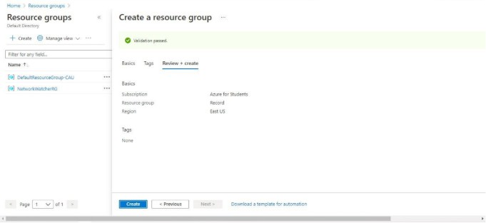

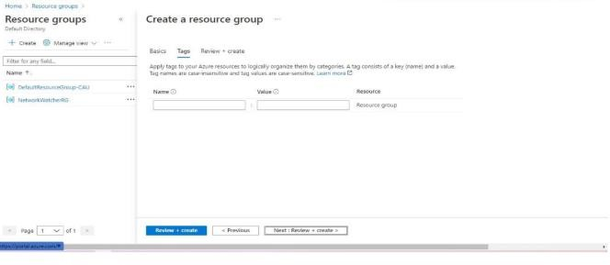

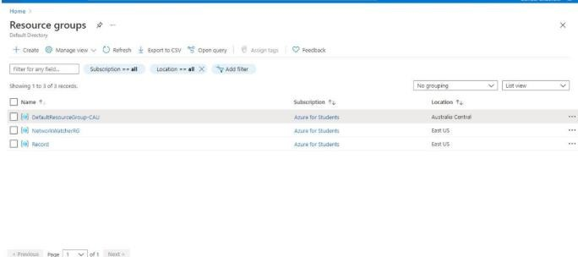

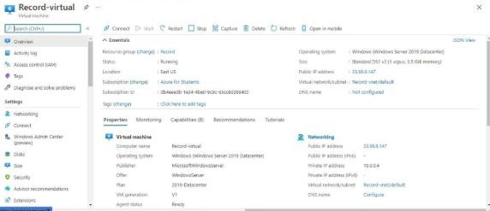

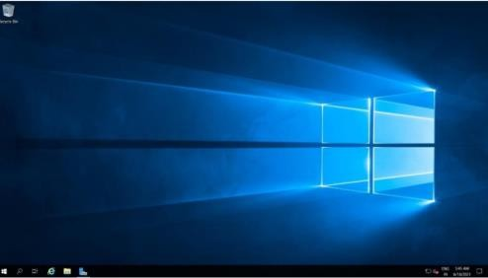

Result:
Platform as a Service (PaaS) create and configure a new VM Image in any Public Cloud Service Provider using Azure has been demonstrated.

